Z-800F Infusion Pump Patient Guide
- Power on Pump by pressing ON/OFF key for 2 seconds.
Prepare Tubing: Do not use prime button to prime tubing.
- Spike bag and PRIME tubing by gravity before loading into pump. Squeeze drip chamber 2/3 full, then slowly open roller clamp to prime. After tubing is primed engage both the roller clamp and white clamp.
Load Set
- Open door of pump.
- With thumb, press green button and slide white clamp, with wings facing up, into loading module.
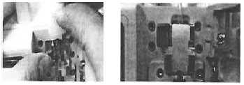
- With fingertip, push tubing into guides, and into black air sensor, aligning tubing on top of Pump based free flow clamp at the bottom. Do not force tubing into clamp.
- Secure door by pushing down on door handle.
Choose New Infusion by highlighting using arrow, press OK. Then input infusion program.
- Choose either: (by highlighting)
  - Cont Mode R/V
  - Cont Mode T/V
  - TPN mode
- Press SELECT
Pri Rate 0000 means primary rate of infusion. Use the number keys 100-10-1 to input rate.
(Example: Rate of infusion 166 = Press 100 once + 10 six times + 1 six times)

Pri VTBI 0000 means Primary volume to be infused. Highlight by pressing the .
Use number keys 100-10-1 to input volume. (Example: Volume to be infused 250 = 100 twice + 10 five times)
Press Run/Stop to start infusion.
To power OFF press ON/OFF key for 2 seconds.

